Kara Burns
Veronica Steinmetz
Mrs. Candela
Web Design
November 20, 2014
Shabby to Chic
Introduction
Graphic designer Steve Supple said, “Nothing is what it was intended to be, in the hands of a creative person.” This quote is perfect for our theme of our website in repurposing old items into room décor. Some people would just trash old items not knowing that they could reuse those items in a creative way. In our web design class we were required to create a website from a blank page in notepad++ all tied around the theme of repurposing, however we will be outlining not only our experience in creating our website but, how we chose on the overall theme of our website, our favorite code, layout decisions, our logo and banner, our struggles with Photoshop, our struggles with coding, and how we used creativity and innovation.
Page 1: Index
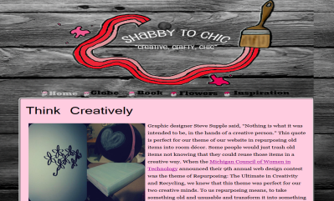
With our website we wanted to choose a theme that showed creativity, and that tied in with the theme of this year’s competition, Repurposing: The Ultimate in Creativity and Recycling. With our two creative minds we made our theme, repurposing old items and turning them into room décor! However the items that we choose are items that everyone is sure to have but not might be using them. Coding was most definitely the hardest thing to learn because if you didn’t have every part of the code correct it wouldn’t work. However some sections of coding we excelled in and favored, like the rollovers. One of our favorite codes was creating the bucket rollovers because you were able to place the rollover un-finished and look at it on our website then go back to the code and finish it; it was our favorite code because we were able to look at our progress as we went along.
Page 2: Globe
Our logo had to be the most creative thing on the website because we wanted it to pop out and show our creativity ability. We chose our logo to be a paint brush painting along pink stripes to match our color theme and we wanted our rollovers to be paint buckets so we decided on the paint stripes to tie in our overall theme of repurposing and making old rusty items into new room décor. We chose a “pink” theme because we wanted it to represent purity and femininity because our theme of room décor was targeted towards girls with our flower wall decal, globe and our jewelry box, so we thought that a pink theme was perfect! When it came to our layout choices we wanted to make sure that it was neat, organized and eligible. We made sure that the first thing that you saw on all of our pages was our repurposed items. Also all of our supplies lists were in an unordered list so that we were able to fit our slide show in and make it look good. We wanted to stick to the basics when it came to the footer and where we placed our banner, so we placed our footer at the bottom of our page and our banner/logo at the top.
Page 3: Book
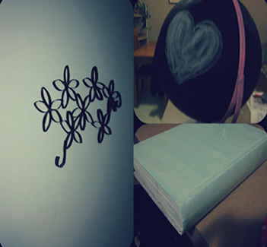
Photoshop was our favorite accessory to use when creating our website; however it was also our biggest struggle when creating our rollovers. When we had first put our rollovers on our website we had a more colorful background so our black text was more noticeable, but when we decided on our wood background the black text was very hard to read. Another struggle we had was making sure that none of the white spots were showing up around the bucket handle. The hardest thing in Photoshop with our rollovers was making sure that each rollover was sized exactly the same from bucket size to text. With Photoshop the rollovers are what took us the longest also. While Photoshop was our favorite tool to use we had some good things come out of it. Our favorite edited photo was our collage of all of our finished repurposed items. This was our favorite photo because all of the pictures in that photo before we photo shopped them looked awful, but after fixing them up in Photoshop they looked really good, and when we collaged them it was easy to say that this is our favorite edited photo.
Page 4: Flowers
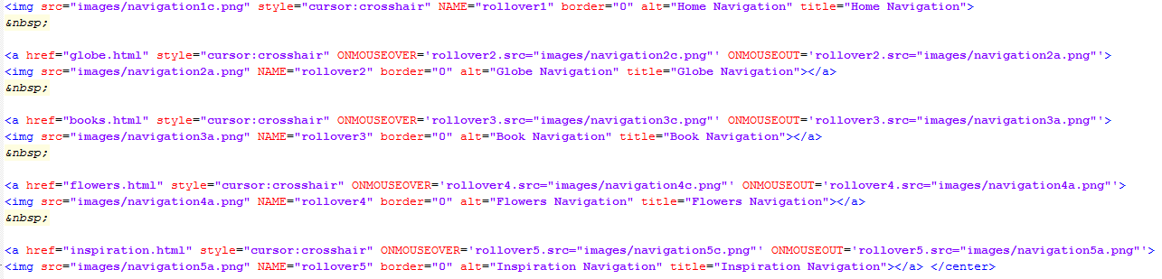
Although our favorite code was the rollover code, it was also the one code that we struggled with the most. Everything on that code had to be perfect every time for it to work. Sometimes the rollovers would work on one page but not the others or all of them worked except one. Finding all of our silly little mistakes in the code was a big problem for us. During the trimester we had a ton of those ah-ha moments with finding our mistakes. We would spend a good ten minutes trying to figure out what was wrong with it. It took the both of us and sometimes Mrs. Candela to actually figure out what was wrong with the codes. As we went through the codes on our pages we realized that it needed quotations or an equal sign or something. However coding was our biggest struggle; everything turned out how we wanted it to in the end.
Page 5: Inspiration
As we built our website we always needed hex codes for the color we wanted. Looking through our citations we believe that the Web Monkey color charts were the most useful. We used this website for all the hex codes used on our website and in Photoshop. Using Photoshop was one way that we were able to use one of the NETS benchmarks; Creativity and Innovation. Although all the NETS benchmarks were all met we think that creativity and innovation was the most important. Creativity and innovation is important in this class because you have to use your creativity, especially in web design.
Conclusion
During the Web Design process we enjoyed being able to see our progress as we worked on our website. Based on feedback we have got from our teacher, peers and our self evaluation we feel that our strengths are being able to work together and put our individual skills together to get something done. Together we also have individual weaknesses and also weaknesses together which include not being able to problem solve when necessary. If we were able to start the contest over we would change small things like our background or our rollovers. In the future we will both use this experience to create a website for our work. This contest has benefited us not only in technology knowledge but as a person. We have grown a lot in our creativity skills and in being able to work together.

